Software Requirements Specification

for

Show management system, Release 1.0

Version 1.0 approved

Prepared by Group 6

Process Impact
July 10, 2026

Table of Contents
Revision History ii
1. Introduction 1
1.1 Purpose 1
1.2 Document Conventions 1
1.3 Project Scope and Product Features 1
1.4 References 1
2. Overall Description 1
2.1 Product Perspective 1
2.2 User Classes and Characteristics 2
2.3 Operating Environment 3
2.4 Design and Implementation Constraints 3
2.5 Assumptions and Dependencies 3
3. System Features 3
3.1 Show Scheduling 3
3.1.1 Description 3
3.1.2 Functional Requirements 3
3.2 Online Ticket Booking and Payment 5
3.3 Gate Operations 5
3.4 Revenue Reporting 5
4. Data Requirements 6
4.1 Logical Data Model 6
4.2 Data Dictionary 6
4.3 Reports 9
4.3.1 Revenue and Ticket Sales Report 9
4.4 Data Integrity, Retention, and Disposal 9
5. External Interface Requirements 10
5.1 User Interfaces 10
5.2 Software Interfaces 10
5.3 Hardware Interfaces 10
5.4 Communications Interfaces 10
6. Quality Attributes 11
6.1 Usability Requirements 11
6.2 Performance Requirements 11
6.3 Security Requirements 11
6.4 Safety Requirements 11
6.5 Availability Requirements 11
6.6 Robustness Requirements 11
Appendix A: Analysis Models 12

Revision History
Name | Date | Reason For Changes | Version
Tuan Hung | 10/7/2026 | Initial draft | 1.0 draft 1
Manh Dung | 10/7/2026 | Added Data Requirements, External Interface Requirements, and Quality Attributes sections | 1.0 draft 2

Introduction

Purpose
This SRS describes the functional and nonfunctional requirements for software release 1.0 of the Show Management System (SMS). This document is intended to be used by the project team members who will implement and verify the correct functioning of the system.

Document Conventions
No special typographical conventions are used in this SRS.

Project Scope and Product Features
The SMS will completely digitalize the entertainment experience for the water park, eliminate unnecessary manual processes, optimize operational productivity, and increase revenue. Major features scheduled for Release 1.0 include:
- Show Scheduling.
- Online Ticket Booking.
- Gate Operations (Ticketing & Verification).
- Revenue Reporting.
- Payment Integration.

References
- SMS Vision and Scope Document
- SMS Use Cases
- SMS Business Rules

Overall Description

Product Perspective
The Show Management System is a new software system that replaces the current manual management processes, leaflet marketing, and gate queuing. The system integrates with third-party digital payment gateways, specifically MOMO and VNPAY, to process online ticket transactions.
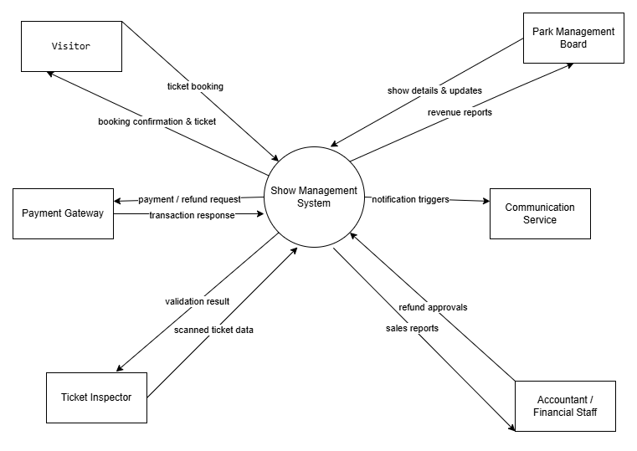

Figure 1. Context diagram for release 1.0 of the Show Management System.

User Classes and Characteristics
Visitors/Tourists | Process Impact customers who want to view show schedules and book tickets quickly without queuing. They require an Internet connection to access the system.
Park Management Board | Require a centralized dashboard to create show schedules, update information, and track automatic revenue reports.
Ticket Inspectors / Customer Service Staff | Perform fast ticket checking processes at the entrance gates using a dedicated verification interface.
Accountants / Financial Staff | Require transparent transaction logs to extract reports quickly and automate revenue reconciliation.

Operating Environment
OE-1: The SMS shall be accessible via a web browser or mobile device for visitors viewing schedules and booking tickets.
OE-2: The system relies on the user having an active Internet connection (Wi-Fi, 4G/5G).

Design and Implementation Constraints
CO-1: Core functions, including ticket booking, payment, and ticket validation, must operate with 100% accuracy.
CO-2: The project will only use the park’s existing internal IT team for development.
CO-3: The system must strictly separate revenue generated from Online Payment Gateways (MOMO, VNPAY) and direct Cash at the Gate for reconciliation purposes.

Assumptions and Dependencies
AS-1: 90% of customers use a smartphone and possess a banking account.
DE-1: Customers prefer to buy tickets online rather than queuing at the gateway.
DE-2: The operation of online bookings depends entirely on the stability of payment systems like MOMO or VNPAY.

System Features

Show Scheduling

Description
Provides tools for the management board to quickly create, update, and broadcast weekly show schedules to visitors, as well as cancel sessions if necessary.

Functional Requirements
Schedule.Create: Creating a new show schedule
.Auth: The SMS shall verify that the user is an authenticated Show Manager before allowing access to the scheduling dashboard.
.Input: The SMS shall prompt the Manager to input the show details: Show Name, Venue, Start Time, End Time, Maximum Capacity, and Ticket Price.
.TimeCheck: The SMS shall validate the time format and ensure that the start time is strictly earlier than the end time (see BR-7).
.Conflict: The SMS shall check the database to ensure the selected venue is not occupied by another show during the overlapping time period (see BR-8).
.Store: Upon successful validation, the SMS shall generate a unique Show ID, save the show details to the database, and set its status to "Unpublished".
Schedule.Update: Modifying an existing show schedule
.Retrieve: The SMS shall retrieve and display the current details of the selected show in an editable form.
.CapacityCheck: If the Manager attempts to reduce the Maximum Capacity, the SMS shall block the update if the new capacity is below the current number of sold tickets (see BR-11).
.NotifyCheck: If the time or venue of a show with existing bookings was altered, the SMS shall trigger the communication service to automatically notify all affected ticket holders (see BR-30).
.Save: The SMS shall save the updated details to the database after ensuring no time or venue conflicts exist.

Schedule.Cancel: Cancelling a show session
.Prompt: The SMS shall prompt the Show Manager to enter a reason for cancellation (e.g., weather, technical issues) and confirm the action.
.Status: The SMS shall update the show status to "Cancelled".
.HaltSales: The SMS shall immediately prevent any new bookings (Online or Gate) from being accepted for the cancelled session (see BR-21).
.Notify: The SMS shall identify all "Confirmed" bookings for this show and trigger the Communication Service to send Push/SMS/Email notifications to affected visitors.

[Note: Functional requirements for archiving historical show data and configuring complex recurring weekly schedules are not provided in this example.]

Online Ticket Booking and Payment

Description
Visitors can view broadcasted show schedules, select ticket quantities, and complete the payment process through an approved payment gateway.

Functional Requirements
Book.View: Viewing show schedules
.Display: The SMS shall display a list of "Published" shows with essential details: Show Name, Venue, Start/End Time, Ticket Price, and Availability Status.
.Empty: If no shows are available for the selected date, the SMS shall display a message prompting the Visitor to choose another date.

Book.Place: Placing a ticket booking
.Select: The SMS shall allow the Visitor to select a show and specify the ticket quantity.
.Price: The SMS shall calculate and display the total price, calculated as Ticket Price multiplied by Quantity (see BR-25).
.Capacity: The SMS shall inform the Visitor and block the booking if the requested quantity exceeds available capacity or if the show is sold out (see BR-11, BR-12).

Book.Pay: Processing ticket payment
.Method: The SMS shall display available payment methods and redirect payment information to the selected approved payment gateway.
.Confirm: Upon a successful transaction response from the Gateway, the SMS shall record the payment, automatically update the booking status to "Confirmed" (see BR-29), and generate a confirmation notification.
.Timeout: The SMS shall automatically expire a pending ticket booking and change its status to "Cancelled" if the payment is not successfully completed within 10 minutes of checkout initiation (see BR-34).
.Fail: If the payment request is rejected, the SMS shall display a failure message and allow the Visitor to retry or cancel, while keeping the booking status as "Pending Payment".
[Note: Functional requirements for applying marketing discount vouchers, purchasing combo tickets covering multiple services (planned for Release 2 and 3), and user-initiated booking modifications are not provided in this example.]

Gate Operations

Description
Authorized staff validate a visitor's ticket at the entrance gate before allowing entry to a show session.

Functional Requirements
Gate.Auth: Staff authorization and restrictions
.Access: The SMS shall ensure that only authorized staff can access the gate operation interface to validate or sell tickets (see BR-19).
.Restrict: The SMS shall strictly restrict staff members from modifying ticket prices or existing booking information during operations (see BR-20).

Gate.Sell: Selling tickets directly at the gate
.Select: The SMS shall allow the Ticket Inspector to select the current active show session and specify the ticket quantity for walk-in visitors.
.NoInfo: The SMS shall process the ticket purchase at the gate without requiring visitors to provide any personal information (see BR-23).
.Capacity: The SMS shall block the sale if the requested quantity exceeds the remaining capacity or if the show has reached 100% capacity (see BR-11, BR-12).
.Record: Upon successful payment, the SMS shall generate the ticket and record the revenue specifically as direct Cash at the Gate for reconciliation purposes (see BR-33).
Gate.Validate: Validating tickets for entry
.Input: The SMS shall allow the Ticket Inspector to scan the ticket barcode or QR code, or manually enter the ticket ID.
.Verify: The SMS shall verify that the scanned ticket belongs to the specified show session and prevent entry if it does not match (see BR-16).
.CheckUsed: The SMS shall check if the ticket has already been used; used tickets cannot be reused, and entry shall be denied (see BR-17, BR-18).
.Update: Upon successful validation, the SMS shall mark the ticket as "Used", record the validation event, and display a success message to allow entry.

[Note: Functional requirements for offline ticket scanning during network outages and manual ticket re-issuance for lost tickets are not provided in this example.]

Revenue Reporting

Description
The system automates the recording of transaction logs and allows financial staff to audit refunds and export sales reports.

Functional Requirements
Report.View: Generating revenue summaries
.Calculate: The SMS shall calculate Total Revenue (sum of all successful ticket transactions) and Net Revenue (Total Revenue minus Total Refund Amount) (see BR-27, BR-28).
.Separate: The SMS shall strictly separate revenue generated from Online Payment Gateways (MOMO, VNPAY) and direct Cash at the Gate (see BR-33).
.Empty: The SMS shall inform the user if no transactions match the selected date or category filters.

Report.Export: Exporting sales reports
.Format: The SMS shall request report criteria and allow Financial Staff to select a date range and export the sales report in PDF, Excel, or CSV format.
.Download: The SMS shall retrieve the sales data, generate the report file, and provide a secure download link for the user.

Report.Refund: Auditing refund transactions
.Audit: The SMS shall display a list of pending refund transactions for the Accountant to verify transaction details against the external payment gateway's portal (see BR-32).
.Approve: Upon approval by the Accountant, the SMS shall update the status to "Approved", trigger the Payment Gateway API to execute the fund transfer, and record the refund in the financial report (see BR-22).
.Reject: If the Accountant detects a data discrepancy and clicks "Reject Refund", the SMS shall prompt for a reason, update the status to "Rejected", and flag the transaction for further investigation.

[Note: Functional requirements for custom report building, automated email delivery of daily reports, and direct integration with third-party accounting software are not provided in this example.]

Data Requirements

Logical Data Model
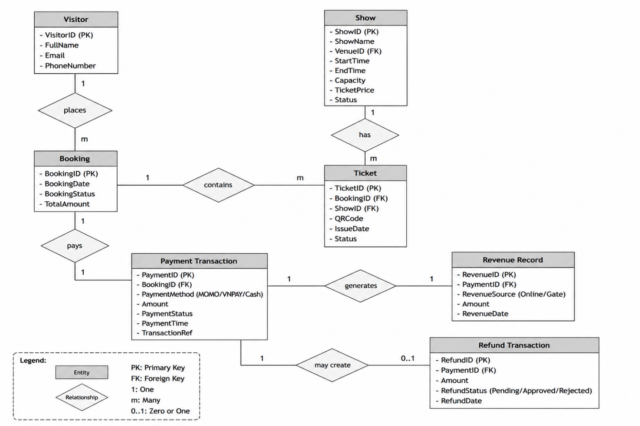

Data Dictionary
Data Element | Description | Composition or Data Type | Length | Values
Show ID | Unique identifier assigned to each show | Integer | 10 | Auto-generated
Show Name | Name of the show session | Alphanumeric | 100 | -
Venue | Location where the show is held | Alphanumeric | 100 | Registered venue names
Start Time | Starting time of the show | DateTime | 19 | yyyy-MM-dd HH:mm
End Time | Ending time of the show | DateTime | 19 | yyyy-MM-dd HH:mm
Capacity | Maximum number of visitors allowed | Integer | 5 | Greater than 0
Ticket Price | Price of a single ticket | Decimal | 10,2 | Greater than 0
Booking ID | Unique booking identifier | Integer | 10 | Auto-generated
Booking Status | Current booking state | Alphabetic | 20 | Pending Payment, Confirmed, Cancelled
Ticket ID | Unique identifier of ticket | Integer | 10 | Auto-generated
Ticket Status | Current ticket state | Alphabetic | 20 | Valid, Used, Cancelled
Payment Method | Payment method used | Alphabetic | 20 | MOMO, VNPAY, Cash
Revenue Source | Source of generated revenue | Alphabetic | 20 | Online, Gate
Refund Status | Refund processing state | Alphabetic | 20 | Pending, Approved, Rejected

Reports

Revenue and Ticket Sales Report
Report ID | SMS-RPT-01
Report Title | Revenue and Ticket Sales Report
Report Purpose | Provide revenue statistics and ticket sales information for management decisions
Priority | High
Report Users | Accountant, Financial Staff, Park Management Board
Data Sources | Payment Transactions, Booking Records, Refund Transactions
Frequency and Disposition | Generated on demand or periodically (Daily, Weekly, Monthly)
Latency | Report shall be generated within 5 seconds
Visual Layout | Landscape mode
Header and Footer | Report title, generation date, selected period, page number
Report Body | Total Revenue, Net Revenue, Online Revenue, Gate Revenue, Refund Amount, Tickets Sold, Occupancy Rate
Selection Criteria | Date range, Show Category, Revenue Source
Sort Criteria | Reverse chronological order
End-of-Report Indicator | None
Interactivity | Export to PDF, Excel, CSV
Security Access Restrictions | Only Accountants and Management Board may access or export reports

Data Integrity, Retention, and Disposal
DI-1: Booking records shall be retained for at least 12 months after the show date.
DI-2: Payment transaction records shall be retained for at least 5 years for financial auditing purposes.
DI-3: Refund transaction records shall be retained for at least 5 years.
DI-4: Ticket validation logs shall be retained for 12 months after the show session ends.
DI-5: Cancelled or expired bookings shall be archived instead of permanently deleted.
DI-6: Personal information shall be protected according to applicable privacy regulations.

External Interface Requirements

User Interfaces
UI-1: The system shall provide separate interfaces for Visitors, Managers, Ticket Inspectors, and Accountants.
UI-2: The system shall support responsive web interfaces for desktop, tablet, and mobile devices.
UI-3: The booking interface shall display show schedules, ticket availability, and pricing information clearly.
UI-4: The management dashboard shall provide charts and summary statistics for operational monitoring.
UI-5: QR codes shall be displayed clearly for ticket validation purposes.

Software Interfaces
SI-1: The system shall integrate with MOMO payment gateway.
SI-2: The system shall integrate with VNPAY payment gateway.
SI-3: The system shall integrate with Email notification services.
SI-4: The system shall integrate with SMS notification services.
SI-5: The system shall support exporting reports in PDF, Excel, and CSV formats.

Hardware Interfaces
HI-1: Ticket inspectors shall use QR scanners or mobile devices capable of scanning QR codes.
HI-2: The system shall support standard desktop and laptop computers used by management staff.
HI-3: Visitors shall be able to access the system through smartphones, tablets, or personal computers.

Communications Interfaces
CI-1: The system shall use HTTPS for all communications involving personal or financial information.
CI-2: The system shall send booking confirmations via Email or SMS.
CI-3: The system shall send notifications when shows are cancelled or rescheduled.
CI-4: The system shall notify visitors when refunds are approved and processed.
CI-5: The system shall support communication with external payment gateways through secure APIs.

Quality Attributes

Usability Requirements
USE-1: New users shall be able to complete an online booking without assistance.
USE-2: The system shall provide intuitive navigation and simple workflows.
USE-3: The booking process should require no more than five user interactions before payment.

Performance Requirements
PER-1: The system shall support at least 500 registered users.
PER-2: The system shall support at least 100 concurrent users during peak hours.
PER-3: 95% of pages shall load within 3 seconds under normal operating conditions.
PER-4: Ticket validation shall complete within 2 seconds after QR scanning.

Security Requirements
SEC-1: All payment and personal information shall be encrypted during transmission.
SEC-2: Only authenticated users may access management functions.
SEC-3: Role-based authorization shall be enforced throughout the system.
SEC-4: Only authorized accountants may access revenue reports.
SEC-5: Passwords shall be securely hashed before storage.

Safety Requirements
SAF-1: The system shall prevent duplicate ticket validation.
SAF-2: The system shall prevent ticket sales beyond show capacity.
SAF-3: Financial transactions shall be recorded and auditable.

Availability Requirements
AVL-1: The system shall maintain at least 99% availability excluding scheduled maintenance periods.
AVL-2: Scheduled maintenance shall be announced in advance whenever possible.

Robustness Requirements
ROB-1: If payment gateway communication fails, the booking shall remain in "Pending Payment" status.
ROB-2: The system shall recover gracefully from temporary network failures.
ROB-3: The system shall log all critical errors for investigation and auditing purposes.
ROB-4: Failed refund operations shall remain pending and allow retry attempts by accountants.

